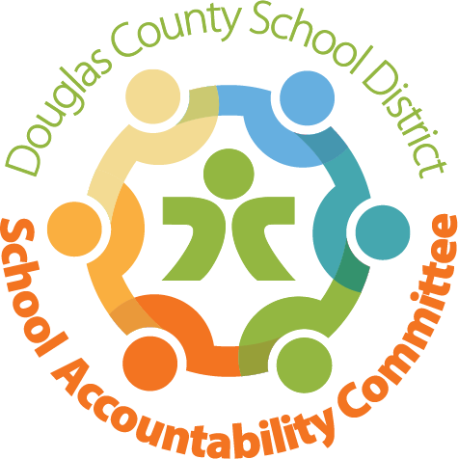
SAC Committee:
Karen Rainey – Chairperson  Chris Kuppel – Co-Chairperson  Kristi Hepting - Recorder  Chris Foye – DAC Liaison | Molly Gnaegy – Principal  Katie Sodaro-Jensen – Assistant Principal  Teacher – Mrs. Dawson  Parent-Roger Smith
Meeting Logistics/Chair: 5-10 min
- Approval of prior meeting minutes

Administration Update: Molly Gnaegy/Katie Sodaro- Jensen - 45 min

- Safety Update from Katie Sodaro-Jensen-Assistant Principal

Discussion surrounding safety issues with pick up and drop off were a major priority of this SAC meeting. Mrs. Katie Sodaro Jensen shared there are rules regarding DCSD policy versus laws of the county. The back bus loop at dismissal poses the most problems. Recently, there was a sandwich board placed on the street leading to the back loop requesting parents not to park so close to the cross walk. The use of the sandwich board has been somewhat helpful. Teachers have been asked not to park on the street near the back bus loop as well. At times kindergarten and preschool drop off parents are parking in the loop. The town is likely able to paint cross hash markings in the “no parking zone” to increase visibility of the crosswalk. The town may review if they can post additional speed limit signs possibly with blinking lights. A recommendation of having our SRO present at drop off/pick up may help when available

There was a suggestion to go back to having kids use two doors so there is less traffic. Mrs. Katie Sodaro Jensen shared this can be done and is not breaking and policies related to Covid-19. There was a suggestion of possibly putting cones in front and back of the bus. Maybe even asking if the bus can move down the loop so there are not cars in front of and behind the bus. Roger Smith later asked how TBE could possibly raise money for signs that blink and light up. Principal Gnaegy and Roger Smith volunteered to fill out a grant request with the PTO.

Plan: Chris Murphy and Heather Kramarczyk are working on creating fliers. TBE will open only two doors for drop off and pick up. This will help to have more staff on hand with less doors to open. There was a discussion surrounding creating a video with possible student involvement. Teachers can add in information regarding the new drop off and pick up system in their weekly emails to families. In addition, all new information will be shared in TBE weekly notes. Mrs. Dawson noted it may be good to create signs redirecting families/students to door that will be opened.
TBE will be creating a traffic committee. Law enforcement may drop in from time to time to monitor drop off and pick up. Parent education is key! Next year at back to school night there will need to be more parent education.

Question Regarding CMAS Testing
Colorado is requesting to move forward with CMAS Testing. There is a possibility of using other data such as, iReady. The SAC committee agreed iReady is collected during various points of the year and is more dynamic. Nationally there is a request for each state to complete standardized testing and submit data. More information to follow.

Interviews for TBE Principal
There is a link to complete a community survey to gather information regarding principal candidates. There is a second survey to be considered to attend the upcoming principal interviews on Thursday, 3/4/21.

NextSAC Meetings were scheduled in April on 4/20/21 & May on 5/18/21.
Adjournment: Motion to adjourn

