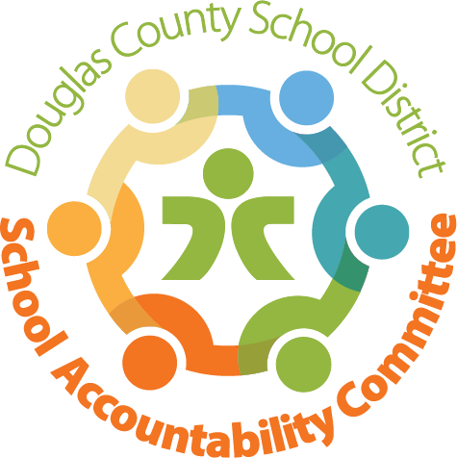
SAC Committee:
Karen Rainey – Chairperson  Chris Kuppel – Co-Chairperson  Kristi Hepting - Recorder  Chris Foye – DAC Liaison  Molly Gnaegy – Principal | Teacher –  Teacher – Mrs. Dawson  Parent –  Parent –Jennifer Baldovinos  Parent – Amanda Cushing

Meeting Logistics:
Approval of prior month’s minutes (Approved)
DAC Update
Chris Foye attended the last DAC meeting. There is no fall forum this year. There were questions and discussion surrounding eLearning families and how to better connect them. The district has asked the SAC portion of each school has a strong website. Good news TBE has a dedicated and updated SAC link for families.
The DCSD Road to Return Dashboard will be updated in a week and more descriptive by feeder.
The Budget shortfall was discussed regarding budgets.
The DCSD Calendar Committee comprised of students, teachers, admin and other staff. The creation and of the calendars were delayed but are not posted on the DCSD website.
By May of 2021 we will need a new SAC Chair
Karen Rainey opened a discussion surrounding needing a new chair during May of 2021. Current SAC members will take this into consideration.
Administration Update: Molly Gnaegy/Katie Sodaro- Jensen
Did we receive new or re-enrollments due to families possibly returning to TBE? Unfortunately, we did not receive new students during October when DCSD when from a hybrid model to full time in person learning in elementary.
For the January semester there are approximately five students who will be switching to eLearning as well as five students returning to TBE.
Currently enrollment was 333 before October count now we are at 328 with 281 in person learners and 47 elearners. TBE is 43 students short. The silver lining is our class sizes are very small.
Kindergarten Orientation will be the first week in December.

TBE would like to hire a health assistance but there is a budget freeze.
The new UIP is almost finalized and will be ready by the end of December. The goals are related to student driven data. Curriculum assessments such as, iReady and Envision Math will be used to create the UIP.
School Safety: There have been two Secure Perimeter drills and two real Secure Perimeters. They went really well! Lockdown drills are occurring as well.
PTO & Family Community Update
The PTO is trying to be creating through the pandemic to keep families connected. TBE PTO and the Family Community group are chairing a Christmas Lights contest to vote on your favorite family home. How fun! More information to come later in the week.
There will be a food drive where families can contribute food or donate money directly online.
Parent Question: How can we recruit more students? Are we able to open enroll students from other districts? Can we share fliers with other nearby areas such as, Sterling Ranch?
New Homeowner Packet could we consider TBE? Could PTO use funds to help recruit more students and pay for fliers? Principal Gnaegy shared a grant to the TBE PTO could be considered.

